**Materials used in the project:**

|  |  |  |  |
| --- | --- | --- | --- |
| **S.No**. | **Name of the device** | **Photo of the Material** | **Specification** |
| 1. | L298N |  | The L298N is a dual H-Bridge motor driver which allows speed and direction control of two DC motors at the same time. |
| 2. | Relay Module |  | Relay module is an electrical switch that is operated by an electromagnet. The electromagnet is activated by a separate low-power |
| 3. | Servo Motor |  | The servo motor is a closed-loop mechanism that incorporates positional feedback in order to control. |
| 4. | Arduino UNO R3 |  | Arduino UNO is a microcontroller board based on the **ATmega328P**. It has 14 digital input/output pins. |

|  |  |  |  |
| --- | --- | --- | --- |
| 5. | Jumper Wires |  | Jumper wires are simply wires that have connector pins at each end, allowing them to be used to connect two points to each other without soldering. |
| 6. | Bo Motors |  | This BO (Battery Operated) Motor is lightweight DC geared motor which gives good torque and rpm at lower voltages. |
| 7. | Heat Sensor |  | It is designed for indicating the fire or heat change and it is used for alerting. It senses the amount of heat energy generated by a system due to the temperature produced either by digital or analog output. |
| 8. | Flame sensor |  | A flame-sensor is one [kind of detector](https://www.elprocus.com/emf-detector-circuit-working-types-and-its-applications/) which is mainly designed for detecting as well as responding to the occurrence of a fire or flame. |

**Fabrication of the project:**

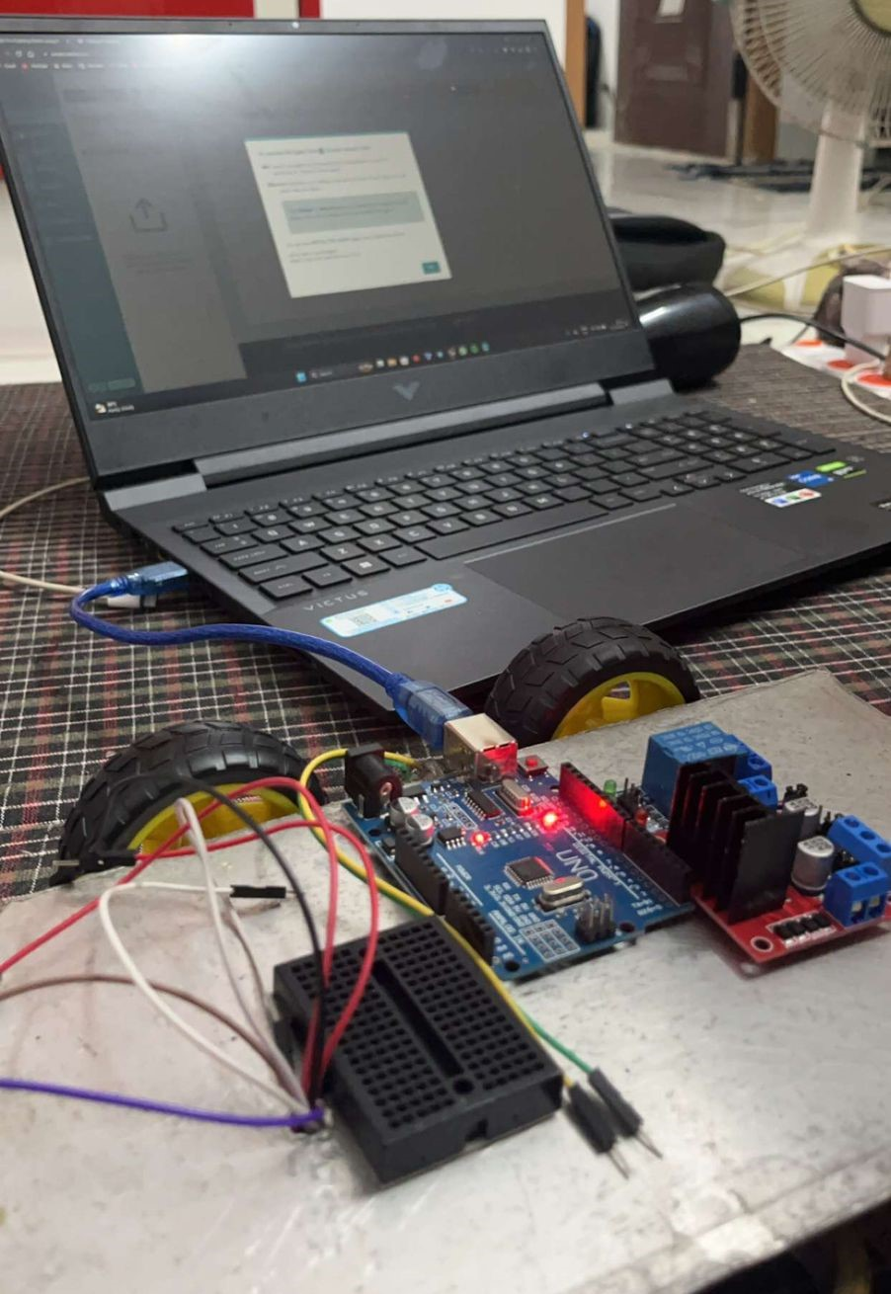

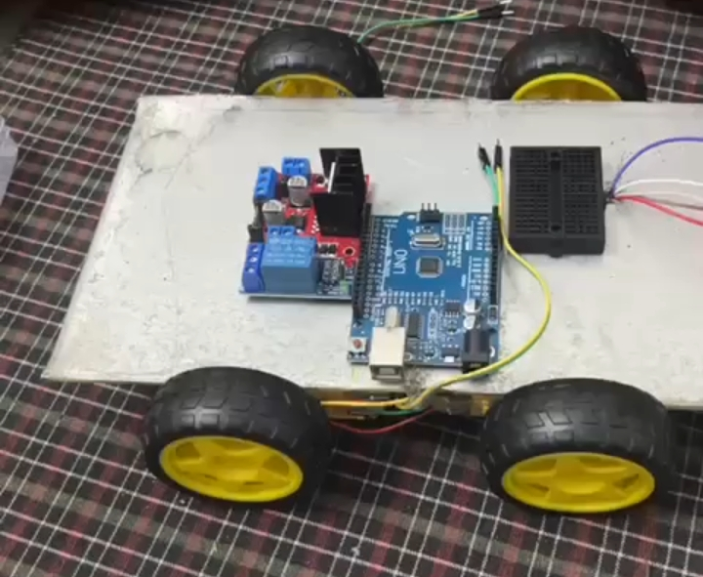

30% Work 60% Work

Fig (1) : Fabrication work, fixing wheels and motor, electrical boards, sensors.

Fig (2) : Fabrication Work, coding for Arduino Component, wires assembling.

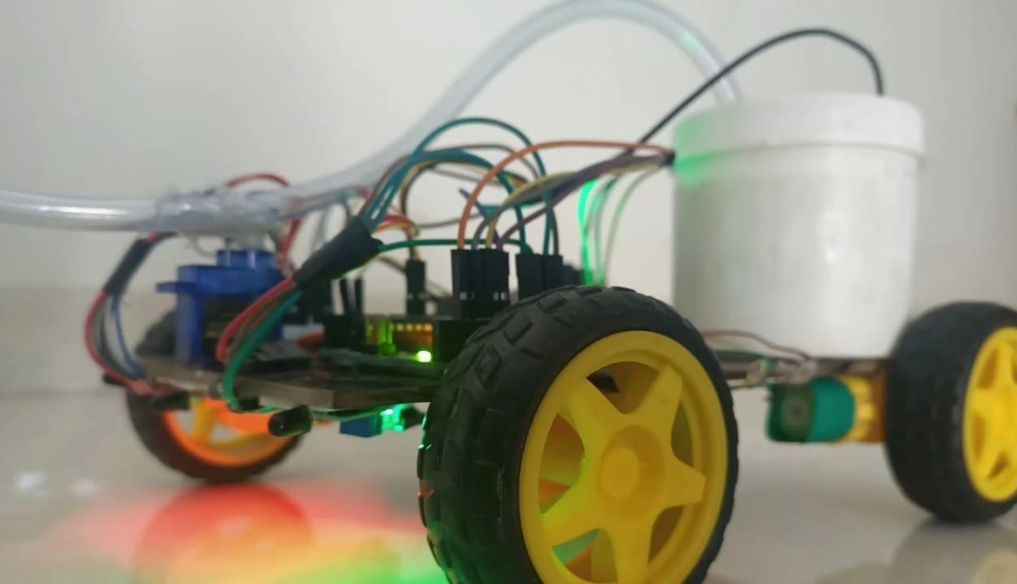

100% Work

Fig (3) : Fabrication work, Testing and final work.